**TECH-A-INTERN : INTERNSHIP OF UI/UX DESIGN DOMAIN**

**NAME : DHANESHWARI SURAJMAL JATOLIA**

**TASKS : LEVEL 1**

**REDESIGN TECH-A-INTERN WEBSITE**

**1.HOME PAGE**

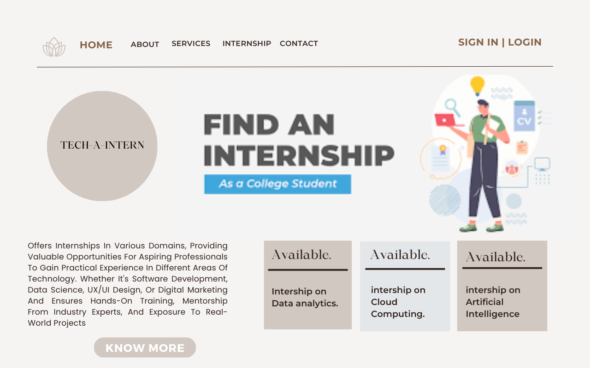

**SO THE IDEA BEHIND CREATING THIS WEBSITE WAS VERY MUCH NEUTRAL AND A COMBINATION WITH PASTELS.HERE IS THE HOME PAGE WHERE WE HAVE THE NAV BAR AT THE TOP WHICH CONSIST OF HOME , ABOUT , SERVICES , INTERSHIP , CONTACT PAGES AND AT THE TOP MOST CORNER WE HAVE SIGN IN AND LOGIN PAGE . BENEATH THAT SOME PREVIEW ABOUT THE WEBSITE.**

**2.ABOUT US PAGE**

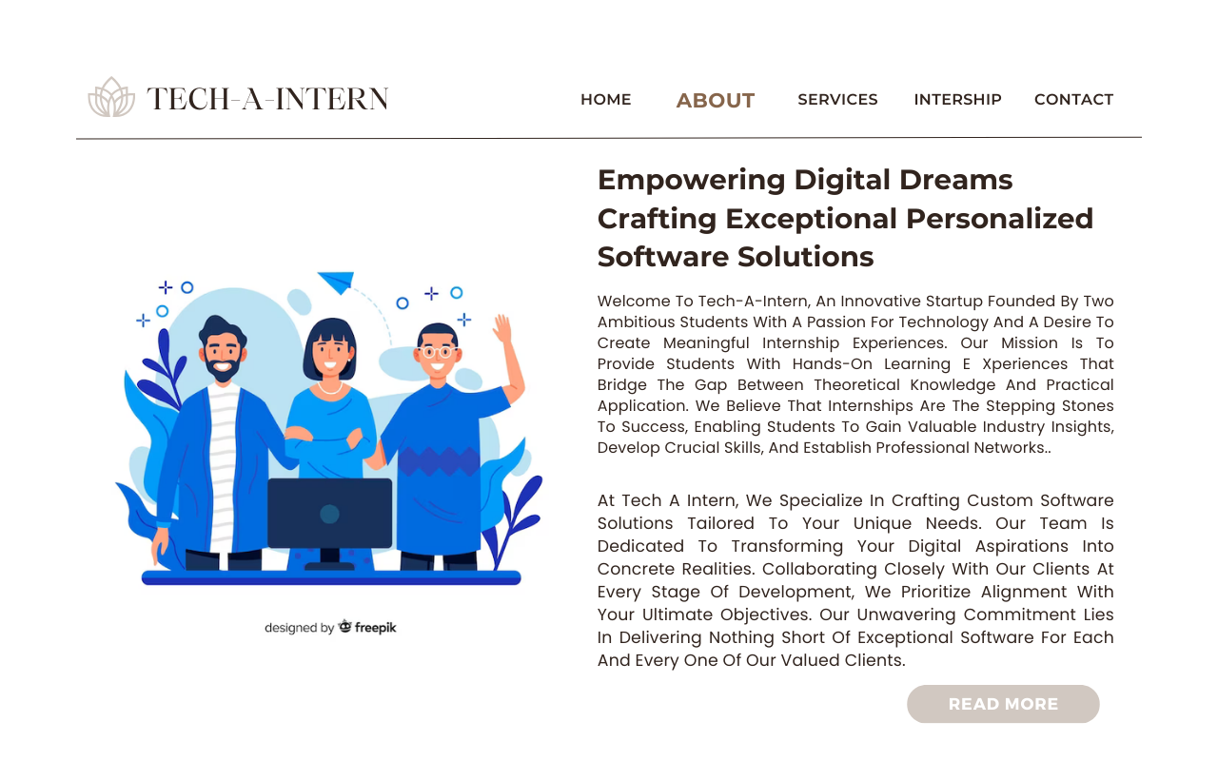

**HERE IS THE ABOUT US SECTION WITH MORE INFORMATION OF THE TECH-A-INTERN WORK**

**AND HAS A EFFECT ON EACH PAGE OF CHANGE THE FONT STYLE AND COLOUR RESPECTIVELY.**

**3.SERVICES PAGE**



**SAME AS THE ABOUT PAGE WITH INFORMATION OF TECH-A-INTER SERVICES GIVE PREVIEW ABOUT THE SERVICES WHICH THEY ARE PROVIDING TO THE STUDENTS IN A VERY CREATIVE WAY WITH THE HELP OF USING POSTER PICTURES.**

**4.INTERNSHIP PAGE**



**THIS PAGE CONSIST DIFFERET DOMAINS INTERSHIPS WHICH TECH-A-INTERN IS PROVIDING HAVING LARGE CATEGORIES OF YOUR CHOICES. BUILD LIKE HAVING FOUR CONATINERS WITH A PICTURE AND NAME PF IT WITH DURATION AND A APPLY BUTTON WHICH WILL REDIRECT YOU TO THE REGISTRATION PAGE. ALSO THERE IS FORWORD BUTTON WHICH WILL SHOW YOU MORE CHOICES.**

**5.CONTACT PAGE**

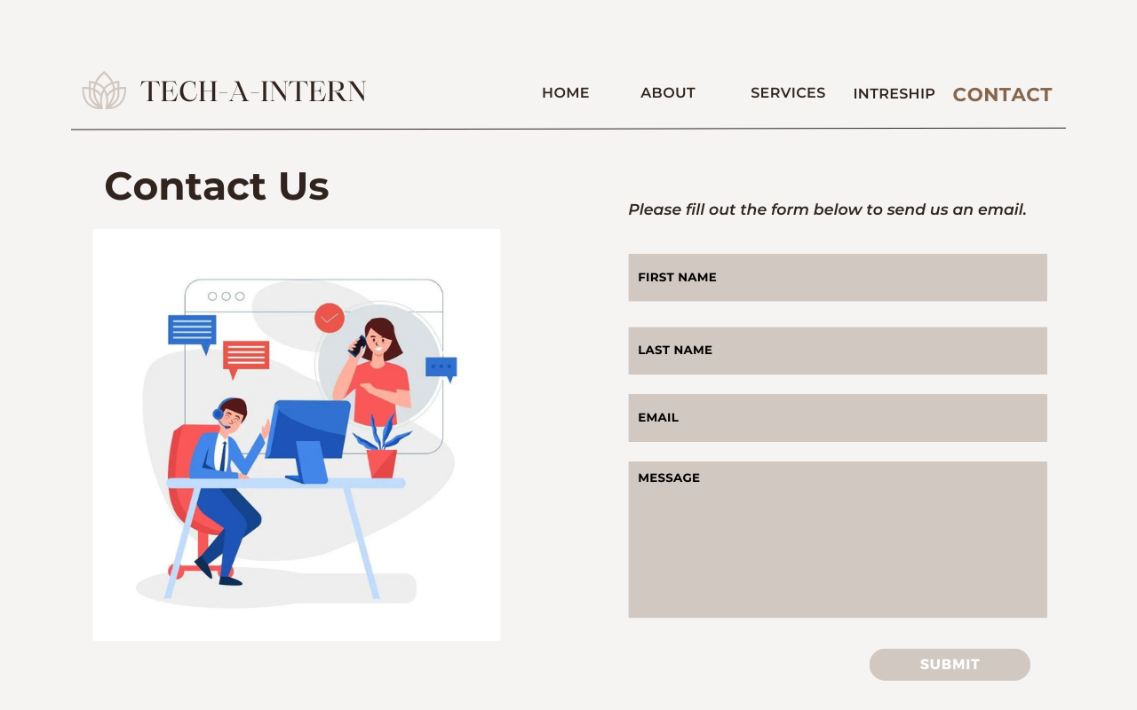

**IT IS A VERY BASIC AND MINIMAL CONTACT PAGE FROM WHICH THE INTERNS CAN CONTACT.**

**THANK YOU.**